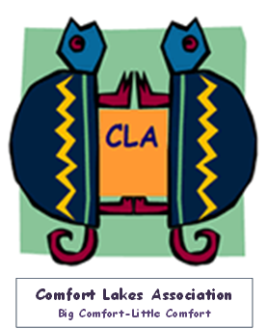

**Comfort Lakes Association**

**Big Comfort-Little Comfort**

